Tittle of the Article

Verma K.K. ^{1*}, Kumar V.D.², Sharma M.K.³ and Mohan N.K.¹
¹First Author’s Affiliation, Address
²Second Author’s Affiliation, Address
³Third Author’s Affiliation, Address
*author@gmail.com (*Corresponding author’s email only)
Abstract [← 12pt, Italic, bold]: Abstract should stand alone, means that no citation in abstract. The abstract should concisely inform the reader of the manuscript’s purpose, its data and methods, its findings, and its implications. The abstract should state briefly 1) the purpose of the research, 2) research design and methodology, 3) the principal results, and 4) major conclusions. An abstract is often presented separately from the article, so it must be able to stand alone. For this reason, non-standard or uncommon abbreviations should be avoided, but if essential they must be defined at their first mention in the abstract itself. The abstract should be relatively non-technical, yet clear enough for an informed reader to understand the manuscript’s contribution. The abstract should be unstructured, that is, one paragraph. An abstract is often presented Separately from the article, so it must be able to stand alone. Non-standard or uncommon abbreviations should be avoided. The abstract should be relatively non-technical, yet clear enough for an informed reader to understand the manuscript’s contribution. The abstract should be unstructured, that is, one paragraph. [← 11pt, Times New Roman, Italic]
Keywords: Word#1, Word#2, Word#3, Word#4, Word#5 [← 12pt, Times New Roman, Italic]

Introduction [Heading ← 12pt, Times New Roman, bold]
Asian Conference on Remote Sensing (ACRS) is a prestigious conference in Photogrammetry, Remote Sensing and Spatial information science. This precious international event is open for any country and region across the globe. The conference is being jointly organized by the Asian Association on Remote Sensing (AARS), the Indian Society of Remote Sensing (ISRS) and the Indian Society of Geomatics (ISG). The theme of ACRS 2026 is “Remote Sensing for Future Earth: Innovation, Inclusion & Impact”. The conference will bring various teams such as students, teachers, professionals, scientists, researchers, inventors, policy makers and entrepreneurs into one platform to promote research findings and exchange their knowledge. Latest technology related products will be showcases in exhibition. This is an excellent opportunity to show your capabilities and achievements in international platform. Through this attempt it provides a forum for local and international scholars to publish high quality research activities in respective fields. [← 12 pt]
Literature Review [Heading ← 12pt, Times New Roman, bold, Line space: after 6pt]
After paper is received from the author, it will be sent to the reviewing board. The associated editors (reviewers) will evaluate the paper on the basis of the following criteria;
- Significance and relevant of the topic to the scope of the ACRS conference.
- Well addressed research problem
- Originality of the content.
- Percentage of Plagiarism
- Relevant and adequacy of the review of literature.
- Proper research methodology adopted
- Organization of the contents
- Quality of writing
- References
- Overall contribution of the research.
After evaluations from associated editors are received, the acceptance or rejection of their research paper will be notified via email to the author/s. [← 12 pt]

Methodology [Heading ← 12pt, Times New Roman, bold, Line space: after 6pt]
Following instructions will have to be adopted by authors of articles when they submit it to the conference:

a. Structure of the Article:
Articles must be set out in the following order – Title, Authors, Affiliations, Abstract, Keywords, Main text under sub-headings including Figure Captions, Figures, and then Tables, Conclusions, Acknowledgements, Appendix, and References.
b. Title Page:
- Title of the article (14 font size)
- Full name(s) of the author(s) (11 font size)
- The affiliation(s) including address (11 font size)
- Active e-mail address of the corresponding author (11 font size)
- Abstract (11 font size)
- Key words (12 font size)

c. Abstract:
- Abstract should be in single paragraph with 300 words without any citation.
- It should be in 11 font size and 1.5 line spaces.
- It should cover the problem, objective, methods, and finding of the study briefly.
d. Key words:
- Please give 4 or 5 key words in alphabetic order by using italic format. (Avoid words like 'and' & 'of').
e. Word Limits:
The length of the article should be between 4000 - 8000 words (including list of references and annexures) and paper containing more than 8000 words will be rejected.
f. Text formatting:
The full article should consist of the major elements, namely: Introduction/ background, problem statement, objective(s), methodology, literature survey, results and discussion, conclusion and references.
All subtopics should be bold and in 12 font size and body of the articles should be typed using 12 font size. Text style should be ‘Times New Roman’ in 1.5 space on one side of A4 paper with normal margins (Top 1”, Bottom 1”, Left 1” and Right 1”).
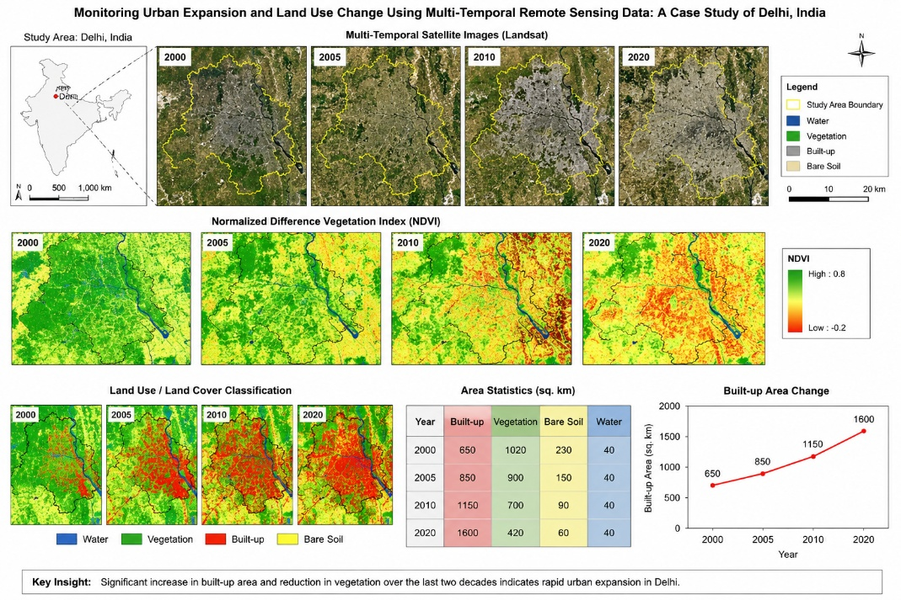
Source: XYZ
Figure 1: Example of a Figure Caption. [← 12 pt]
Results and Discussion [Heading ← 12pt, Times New Roman, bold, Line space: after 6pt]
For Results, provide sufficient detail to allow the results to be meaningful and informative. For Discussion, this should explore the significance of the results of the work, not repeat them. A combined Results and Discussion section is often appropriate. Avoid extensive citations and discussion of published literature. [← 12 pt]
Table Head [← 12 pt, Bold, Center] | Table Head [← 12 pt, Bold, Center] | Table Head [← 12 pt, Bold, Center] | Table Head [← 12 pt, Bold, Center]
Table cells [← 12 pt, Left] | Table cells [← 12 pt, Center] | Table cells [← 12 pt, Center] | Table cells [← 12 pt, Center]
Table cells [← 12 pt, Left] | Table cells [← 12 pt, Center] | Table cells [← 12 pt, Center] | Table cells [← 12 pt, Center]
Table cells [← 12 pt, Left] | Table cells [← 12 pt, Center] | Table cells [← 12 pt, Center] | Table cells [← 12 pt, Center]
Table 1: Example of a Table Caption.[← 12 pt]
Source: Journal of Management
One of the main objects of the discussion is to set forth a complete and plausible explanation or theory for what was found. No one knows the subject of your research as well as you do; on the other hand, the average reader has no time to re-read the discussion if he/she did not understand it the first time around. You do not want the reader to go through your paper several times to understand it. You have to be clear and logical in what you say and explain it in a way that makes sense the first time around. [← 12 pt]

Conclusion and Recommendation [Heading ← 12pt, Times New Roman, bold, Line space: after 6pt]
For Conclusions, the main conclusions of the study may be presented in a short Conclusions section, which may stand alone.

For references authors are expected to adhere to the guidelines of APA (American Psychological Association) 7th edition. Please ensure that every reference cited in the text is also present in the reference list (and vice versa). References should be arranged first alphabetically and then further sorted chronologically if necessary. More than one reference from the same author(s) in the same year must be identified by the letters 'a', 'b', 'c', etc., placed after the year of publication. [← 12 pt]
References [Heading ← 12pt, Times New Roman, bold, Line space: after 6pt]
M.T.M.Rafeek, M. T. M., (2008). Object Oriented Image Analysis for Information Extraction for Urban Land Cover Mapping. Sri Lankan Journal of Geo-Informatics, Volume 05-2008

Reference to an article in online journals or online first [DOI]:
Kushilevitz, E., & Malkin, T. (Eds.). (2016). Lecture notes in computer science: Vol. 9562. Theory of cryptography. Springer. https://doi.org/10.1007/978-3-662-49096-9

Reference to a book (ISBN):
Professor Mennon-Jan Kraak & Perjan Ormeling, (2003), Cartography Visualization of Geospatial Data (Second Edition).

Reference to a thesis for doctorate:
Nickson Perera, M.G.H (2021). Sample thesis name. Sri Lanka: Doctoral dissertation, University of Peradeniya
For published conference proceedings:
M.T.M.Rafeek, M. T. M., (2008). Object Oriented Image Analysis for Building Façade Information Extraction. 29th Asian Remote Sensing Conference, 10-14 November 2008, Colombo, Sri Lanka.

For newspaper articles:
M.T.M.Rafeek, M. T. M., (2003). 1. Introducing Prototype Parcel Based Land Information System Through on Going Titling and Related Services. Survey Journal 74

For Internet resources:
Merriam-Webster. (n.d.). Semantics. In Merriam-Webster.com dictionary. Retrieved January 4, 2020, from https://www.merriam-webster.com/dictionary/semantics

